**Malawi Compost Transporter**

**Preliminary Proposal**

**Husain Aldawood**

**Connor Schmerfeld**

**Hope Williams**

**Shi Zhang**

**Fall 2020**



**Project Sponsor/Faculty Advisor/Sponsor Mentor:** Dianne McDonnell

**Instructor:** David Trevas

# DISCLAIMER

This report was prepared by students as part of a university course requirement. While considerable effort has been put into the project, it is not the work of licensed engineers and has not undergone the extensive verification that is common in the profession. The information, data, conclusions, and content of this report should not be relied on or utilized without thorough, independent testing and verification. University faculty members may have been associated with this project as advisors, sponsors, or course instructors, but as such, they are not responsible for the accuracy of results or conclusions.

# 

# TABLE OF CONTENTS

# Contents

**DISCLAIMER** **1**

**TABLE OF CONTENTS** **2**

**Contents** **2**

**BACKGROUND** **4**

Introduction 4

Project Description 4

**REQUIREMENTS** **5**

Customer Requirements (CRs) 5

Engineering Requirements (ERs) 5

House of Quality (HOQ) 6

Functional Decomposition 7

Black Box Model 7

Functional Model/Work-Process Diagram/Hierarchical Task Analysis 8

**DESIGN SPACE RESEARCH** **9**

Literature Review 9

Student 1 (Shi Zhang) 9

Student 2 (Connor Schmerfeld) 9

Student 3 (Hope Williams) 10

Student 4 (Husain Aldawood) 10

State of the Art - Benchmarking 11

System Level State of the Art - Benchmarking 11

Existing Design #1: Wheelbarrow 11

Existing Design #2: Gorilla Cart 12

Existing Design #3: Cushman Truckster 12

Subsystem Level State of the Art Benchmarking 12

Subsystem #1: Dumping Mechanism 12

Existing Design #1: Wheelbarrow 13

Existing Design #2: Gorilla Cart 13

Existing Design #3: Cushman Truckster 13

Subsystem #2: Tires/Traction 13

Existing Design #1: Wheelbarrow 13

Existing Design #2: Gorilla Cart 13

Existing Design #3: Cushman Truckster 13

Subsystem #3: Motor/Power 13

Existing Design #1: Wheelbarrow 13

Existing Design #2: Gorilla Cart 14

Existing Design #3: Cushman Truckster 14

**CONCEPT GENERATION** **14**

Full System Concepts 14

Full System Design #1: Off-road Self-propelled Wagon 14

Full System Design #2: Bicycle on Tracks 15

Full System Design #3: Off-Road Wagon 15

Subsystem Concepts 16

Subsystem #1: Dumping Mechanism 16

Design #1: Hydraulic System 16

Design #2: Screw Jacks 16

Design #3: Scissor Lift 17

Subsystem #2: Tires/Traction 17

Design #1: Air Filled Tires 17

Design #2: Regular Foam Filled Tires 18

Design #3: Sealant Foam Filled Tires 18

Subsystem #3: Motor/Power 19

Design #1: Operator and Motor Powered 19

**DESIGNS SELECTED – First Semester** **19**

Technical Selection Criteria 19

Rationale for Design Selection 19

**REFERENCES** **21**

**APPENDICES** **24**

Appendix A: All six of the Design Alternatives. 24

Appendix B: Descriptive Title 26

# BACKGROUND

## Introduction

Apart from being a small landlocked nation in Africa’s southeastern region, Malawi is also regarded as one of the world’s poorest countries. For better utilization of organic materials found in this country, residents have set up places for disposing of compostable waste materials. To ensure easy transportation of these compostable waste material, a team of 35 members has been mandated to design and make a tricycle that is able to transport compost to the composting location. The group was acquainted with the customer that will be with us for the degree of the semester and further if the venture is to be proceeded. In the wake of meeting with the customer, the group had the option to concoct imperatives and prerequisites for the plan. Subsequent to gauging the client's needs and designing prerequisites, Team 35 made plan options and scored each with the given measures. This cycle was finished by making diagrams, for example, a morphological framework, pugh outline, and choice grid which would all be able to be seen beneath. This cycle left the group with the last plan that met all of the designing necessities and client requires. A dry cell battery with sufficient capacity will be used to power the tricycle. A rough CAD model was made as a representation of the design in a 3-dimensional view. Cost analysis of the design can also be seen below as well so the team is prepared how much the final design will cost if chosen to manufacture. Through the design process that is shown below, Team 35 has come up with an optimal design that will improve the lives of the people of Malawi. This project proposal is a compilation of all work that was put into the design of the compost transporter in Malawi. The information inside this update start from the earliest starting point of the undertaking, which is the difficult definition. This incorporates the client’s needs, designing prerequisites, and a figure of the QFD that was made joining the two. From that point, the whole plan measure is spread out, including the morphological lattice, plan options, pugh diagram, choice framework, and the last plan. The group was then ready to contemplate distinctive designing investigations of the plan. In the wake of having a harsh drawing of what the last plan will resemble, the group planned a CAD model. From the CAD model, the group had the option to deliver some cost investigation. This incorporates a bill of materials, the assembling cost, the existence cycle cost, the worth examination, and a period estimation of cash. Ultimately on the report will be a code of morals that incorporates the conceivable moral issues the group may experience.

## Project Description

The main goal of this project is to design and make an electrically propelled tricycle that will allow Malawians to transport organic waste materials from their home to compost sites. Organic waste entails but is not limited to garbage, junk, and any other materials considered pollutant to the environment due to their toxicity. The partners for the task incorporate the individuals of Malawi who will be working the vehicle. Another partner is the whole nation of Malawi in light of the fact that, if fruitful, the tricycle will improve the work of the entire Malawian populace. The group accepts that the necessities of the customer and the partners are fundamentally the same as and meet the general objective. To address their issues, the vehicle should be effectively viable and manufactured with some normal homegrown materials to ease fixes. The vehicle additionally should be anything but difficult to work with practically zero electrical information required. Being lightweight and smaller is extremely useful as long as it is as yet ready to keep up a high payload limit and strength. The objective satisfies these necessities by assessing all client requirements and applying an answer for all prerequisites the clients needed.

# REQUIREMENTS

When meeting with the client, the team came up with a list of customer needs that must be met in order to satisfy the client. After the customer needs were developed, the team came up with a list of engineering requirements within the QFD. A more in-depth lists of customer needs and engineering requirements

## Customer Requirements (CRs)

The group met with Professor McDonnell and she gave us a list of requirements that she would like to see in the project. She broke it down into two individual groups: must have, and nice to have. These two lists can be seen below with more detail.

**Must Have:**

* Maintainable
* Manufacturable
* Durable
* Lightweight
* Easy to Operate
* Maneuverable Size
* Operable on Muddy Roads
* Cost within budget
* Durable and Robust design
* Reliable design
* Safe to operate

All of the items in the above list are items that the project needs to have, according to the professor and instructor. It must be maintainable, as Malawi as a poor country and can’t be constantly buying new parts. It must be manufacturable, since the end goal is to be able to make multiple for this country. Durable, lightweight, and operable on muddy roads are all needed because there are basically no paved roads and this design is going to be in constant use. It must be reliable for this same reason, as well. It needs to be safe and easy to operate, as these will be everyday people using this. Finally, it needs to be within the budget of $1,500, as told by the instructor.

**Nice to Have:**

* High Capacity
* Rechargeable
* Reusable Materials Found in Malawi

These “nice-to-have” items listed above were given by the client as things to think about when making this project, but not necessarily adding them in right away. She did this because this project is going to go well past the year this group was given, so she wants this group to give future groups a good jumping off point, where they can hopefully include these if they aren’t already included.

## Engineering Requirements (ERs)

After hearing what the client wanted for this project, the group decided to come up with a list of engineering requirements to think about when designing. The engineering requirements are items that are measurable and items that we are able to discuss, quantitatively. This list can be seen below.

1. Increase Power
2. Small Dimensions
3. Increase Waste Capacity
4. Increase Battery Life
5. Decrease Weight
6. Decrease Manufacturing Cost
7. High Level of Safety

Power is something that the group will constantly need to think about, as this will be dealing heavily with electric motors and carrying a load capacity. The design should have smaller dimensions, but still maximize load capacity for travel as well as storage. This design should take up as little space as possible without making it useless in terms of waste capacity. Along with these items is weight. The design should be as light as possible due to muddy roads and the possibility of getting stuck. The civilians should be able to push or pull the design out, maybe with the help of multiple people. Finally, the group is going to be constantly thinking about the manufacturing cost. This is due to being restricted by the budget, as well as the Customer Need of wanting to one day make multiple.

## House of Quality (HOQ)

After taking all the data, we began to analyze the information and compiled it into a more useful form. This form is known as the QFD chart. This is a chart used by engineers to focus on what they are trying to accomplish. In this chart, the customer needs and engineering requirements of such a device are analyzed and compared in order to better understand what this device needs to do. The scale used in this QFD is a standard scale of importance. After computing the absolute technical importance of each engineering requirement, our team came to the three most important engineering requirements: 1. High level of safety 2.Increase power 3. Small dimensions.

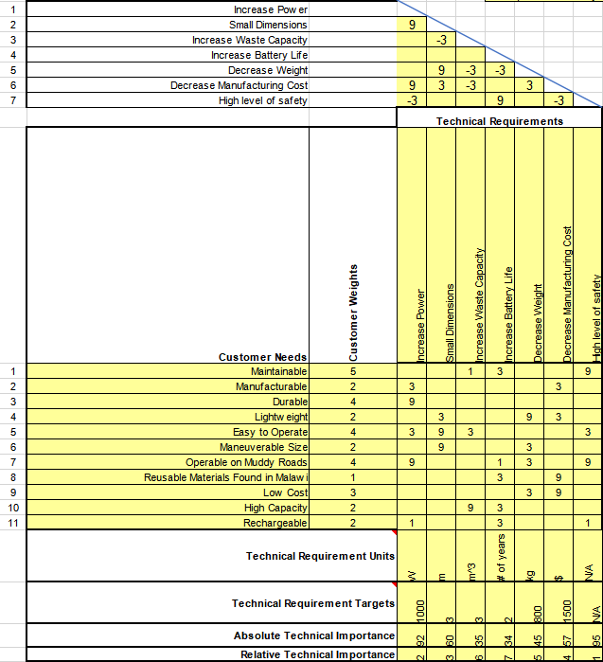

Figure 1: House of Quality

## Functional Decomposition

To start designing a cart which meets all of our customer and client needs, we made a black box model to breakdown the inputs and outputs of this design. Using this information, we made a functional model to further break down the inputs and outputs. A figure of both of these can be seen below as well as a more in depth description.

### Black Box Model

This section discusses the Black Box Model of this project. A Black Box Model allows the group to focus solely on the inputs and outputs of this project without having to worry about the details of how to get from one to another. The Black Box can be seen below.

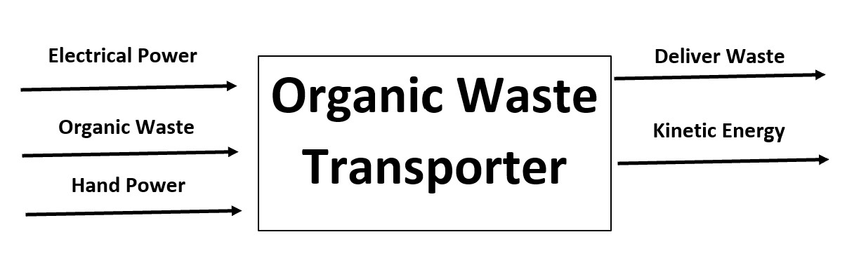

Figure 2: Black Box Model

The primary inputs of the design are electric and hand power, as well as organic waste. The outcome of this design will deliver waste as well as outputting kinetic energy. A Black Box model is important when starting a project because it allows the group to see the bigger picture and get a scope of what the project is going to need. It also allows the group to start thinking about what is inside of the “Black Box”.

### Functional Model/Work-Process Diagram/Hierarchical Task Analysis

### 

Figure 3: Functional Model

A functional model is a graphical description of the functions (or operations) a product must perform on input flows to transform them into desired output flows. Sub-functions may be derived from customer needs. Then solutions to sub-functions can be directly tied to the customer's needs. All in all, according to the function allocation of the functional model, it can help the team to more specifically clarify the availability of designs.

# DESIGN SPACE RESEARCH

In this chapter, a variety of ways to design the project will be discussed. The group each conducted a literature review in which they did their own individual research on certain aspects of the project. With each aspect, the group is able to come together with their newfound knowledge and discuss ways to put each concept together. Following the literature review, a benchmarking analysis was conducted. The group took the time to find products that are already on the market that are relevant to this project. These are products that aren’t necessarily geared towards this specific project, but could be viable options. These are also products that can be useful when designing the final product where the team can pick and choose certain aspects from each item.

## Literature Review

Each student conducted their own literature review. Each one focused on their own specific topic. This was done so that once each student finished, they could come together and discuss their findings. In doing so, they could decide on what may be the best way of going about the design of this project. Each student has described their method, as well as their research below.

### Student 1 (Shi Zhang)

The technical aspect that Shi focused on was the dumping mechanism. What we need to do is to fix one end of the trailer with screws, and then lift up the other end to realize dumping. After a lot of investigation, Shi believes that our team can use jacks, scissor lifts, hydraulic rods, and pulley systems to dump. After consulting the information from different sources, Shi found that when the scissor lift platform is installed and used, the working table should be kept in a horizontal state, [1] which means the trailer can not be placed directly on the working table, otherwise we are lifting rather than dumping. What we can do is to weld the trailer and the working table together, ensuring that the scissor lift can be used safely. The second paper presents a study investigating a screw jack device, traditionally used in mechanical engineering applications, in a structural control application. This device presents an interesting opportunity in the field of structural control, as the screw jack is a low-cost, low-energy alternative to traditional hydraulic actuators. [2] Our budget is limited and our products are designed for people in the Malawi area, so low cost alternatives should be a priority. However, there are disadvantages in using screw jacks. It is well known that vibrations can occur in screw jack mechanisms under certain conditions, especially during downward motion. Several models have been proposed in the literature in order to explain this vibratory phenomenon due to system instability. In order to prevent the mechanism from vibrating, it is sufficient to clamp an inertia mass to the free end of the screw. [3] The other source provides a garbage recycling vehicle with hydraulic lifting rods. The garbage recycling vehicle comprises a compartment main body and a baffle arranged at the upper end of the compartment main body; a motor is installed on one side of a compartment; rotary shafts are connected to the motor and connected with the lifting rods; the lifting rods are provided with lengthening rods. [4] The dynamic analysis of cable-pulley systems is investigated in the last source, the coupled motions between the cable and the movable or fixed pulley are described based on the no-slip assumption and the spatial description. The virtual powers of inertia, gravity and applied forces on the contact segment of the cable, the movable and fixed pulleys are then formulated. [5] According to the author's conclusion, Shi found that the vibration effect has a great influence on the stability of the whole process, the use of pulley system is likely to lead to safety accidents.

### Student 2 (Connor Schmerfeld)

Connor’s main area of focus was the 8020 Aluminum that was recommended by the client. 8020 Aluminum is an aluminum manufacturing company that makes certain profiles that are easy to assemble and disassemble. The task given was to go through a schooling on their website called “8020 University” which allows the user to learn the basics on everything about the 8020 aluminum pieces. Within this course, A variety of important things were learned. It started off by discussing the different types of profiles, the main one being the T-slot, and cross-sections of each part, as well as the pros and cons to each one. Along with the profiles, the engineering specifications were given, such as Young’s modulus and the moment of inertia of each orientation. The course also discussed two other profiles that they sell, ReadyTube and Quick Frame. Each of these may have their uses as well, but the primary focus was the T-slot. This website then discussed the different types of fasteners that they sell, which links the different profiles together perfectly. The rest of the course discussed the doors, panels, and different ways to connect all pieces together that you need. For example, it discusses in depth the best ways to connect “floor-to-frame” and other types of configurations. [6]

After going through the university, Connor was given the task of conducting a beam analysis on 8020 aluminum to see if this material would be feasible. This was done using the moment of inertia and moment to find the max bending stress, then comparing this to the yield strength. The moment of inertia was already given through the university, so all that was needed was the max bending moment. This was found by putting a distributed load onto the beam and constructing a Shear-Force-Diagram and then a Bending-Moment-Diagram[7]. After conducting this analysis on both simply supported and cantilever beams, it was determined that the bending stress on each beam was well below the yield strength, A beam deflection analysis was also conducted and the max deflection for one beam was less than a quarter of an inch[8]. These two results give the group plenty of room to work with when discussing load amounts[9, 10].

### Student 3 (Hope Williams)

The individual analysis Hope has been assigned is to find which motor will best suit the final design based on our current known values and assumptions. This includes researching the different types of motors currently available on the market and listing the pros and cons that come with each motor. With Hope’s research, she believes an AC motor will be the best option for our design. When comparing to a DC motor, Hope has found AC motors take less maintenance and in the long run are cheaper. DC motors have high maintenance costs and extra costs for changing the brushes [14]. Once Hope ruled out DC motors, she looked at DC brushless motors. Hope decided due to the high cost of these motors and the budget we have to also rule them out [15]. If the design advances and is successful in Malawi, a change to DC brushless motors may be a possibility later on in the future. Overall, the AC motors are more reliable, cheaper in the long run, and have a higher life expectancy [16]. Hope researched golf cart motors and electric beach cart motors as this is what our design resembles the most [17]. Once narrowing down the top motors, Hope will calculate the rpm needed, what kind of gearbox is available, the motor power, and the torque using the initial conditions and assumptions the team decides on.

After discussing in more detail with our client Dr. McDonnell, the team has decided to make the final design both human and motor powered. Because the cart doesn’t have to travel far distances from house to house, starting a motor to travel ten feet will not be worth it. The team and client have decided to also make it chain driven [18]. This individual analysis will help the team by making sure the best motor is picked for our future design.

### Student 4 (Husain Aldawood)

The technical analysis assigned to Husain is focusing on the best tires that will best suit the project. choosing the best tires required a lot of research and analysis. With Husain’s research and analysis, it became clear that foam tires would be the best choice for our project. Having foam filled up tires can have two important aspects in the project. The first aspect is that tires filled with foam can avoid punctures. Also, the weight of the foam can be an extra counterweight, which allows the machine to work with more stability in higher altitudes than tires filled with air only [19]. Moreover, tires with foam can act as a sealant between the rubber tire and the wheels. Rims usually are glued with tires that act like a sealant to prevent it from leaking. Glueing the rims is feasible, however, it is not as durable as the seal that comes from the foam [20]. Glue can also be affected by temperature, where high temperature can make it overly stiff and low temperature can increase the modulus of the adhesive [21]. Furthermore, the elasticity of the adhesive must be considered since the adhesive tends to strain and break when temperature increased [22]. Tires can also be a big shock absorber, which can absorb the road shocks that can wear the tire’s tread faster. Tires filled with foam can absorb shocks way more than the tires filled up with air and can have a minimum tear and wear on the thread of the tire [23]. So, tires filled up with foam can be the most durable choice for tires due to its pros over the regular air filled tires.

## State of the Art - Benchmarking

In order to begin the benchmarking process, the group researched products that are already on the market that could be a viable alternative for this project. The three most similar products found were the classic wheelbarrow, the Gorilla Cart, and the Cushman Truckster. Each of these are products that can satisfy multiple needs from the client. However, each of them also have their own downfalls. The following section will discuss each of these pros and cons of each product and how they would not make it a perfect fit for this project.

### System Level State of the Art - Benchmarking

This part discusses existing designs at the system level. Before diving into more detailed subsystems, it is best to start with looking at and comparing each system as a whole. The three existing products, as listed above, will be compared to each other and will discuss how well they fit within the client’s needs.

#### Existing Design #1: Wheelbarrow

This existing design is probably the most basic of them. When someone thinks about carrying compost, a wheelbarrow typically is thought of. A wheelbarrow is a one-wheeled cart that is lifted and guided by a person. The person can both pull or push this design. This meets the customer needs in the way that it is durable, it can carry high loads, and it is cheap and easy to operate. Where this design lacks is in maneuverability and power. The only power given is by the human operating it, therefore the limit is only as high as the strength of the operator. Not only that, but it can be very difficult to maneuver a wheelbarrow through dirt roads and mud.

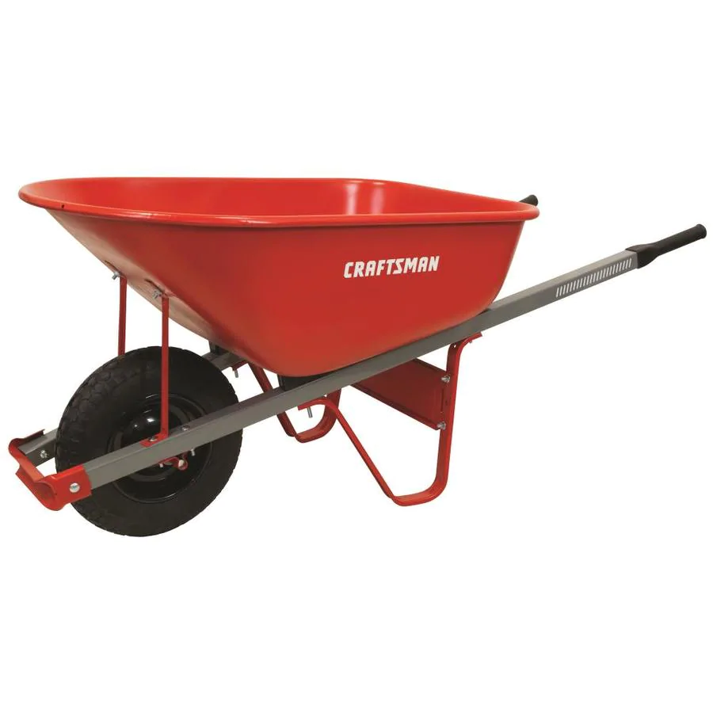

Figure 4: WheelBarrow [11]

#### Existing Design #2: Gorilla Cart

This design is a slightly modified version of the wheelbarrow. It is a four-wheeled cart that can be pulled by an operator. This design fits every need that the wheelbarrow does, but is also more maneuverable. With four wheels instead of one, this design is much easier to control. It even has some options that dump the load using the force of gravity. The downside to this design is that, once again, it relies all on the operator. The limits of how much can be towed relies directly on how strong the person pulling it is.

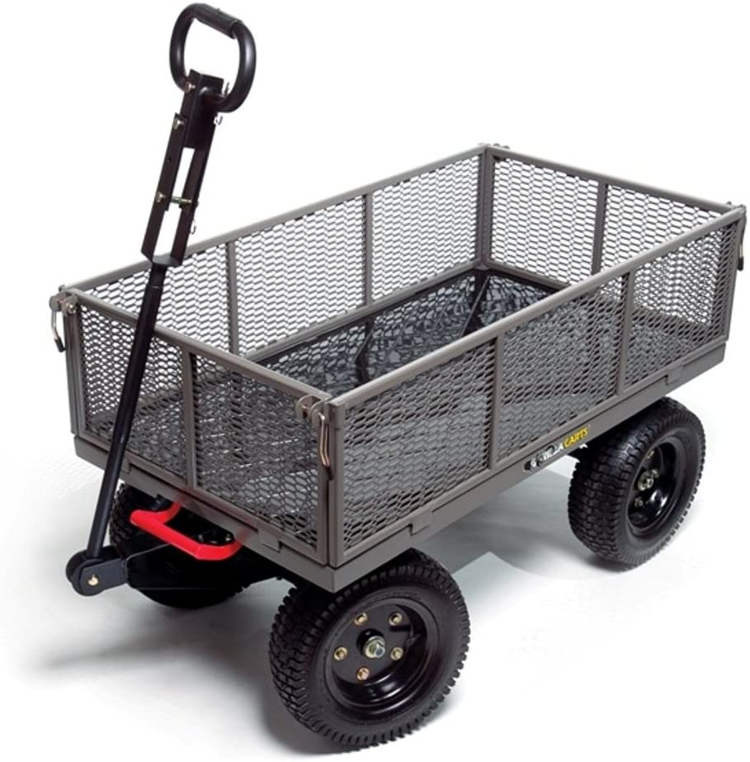

Figure 5: Gorilla Cart [12]

#### Existing Design #3: Cushman Truckster

The Cushman Truckster, as seen below, is another existing design that could meet most of the needs of the client. This is a very durable design, operating on three wheels with a large load capacity. This design is also motorized, which eliminates the human power limit. This also meets the need of being manufacturable. However, this product would not move well in narrow and muddy terrain. It is also a gas powered vehicle which can be very difficult to maintain at such a low cost. It is already not very budget friendly, with this 1954 model below selling for $6,600.

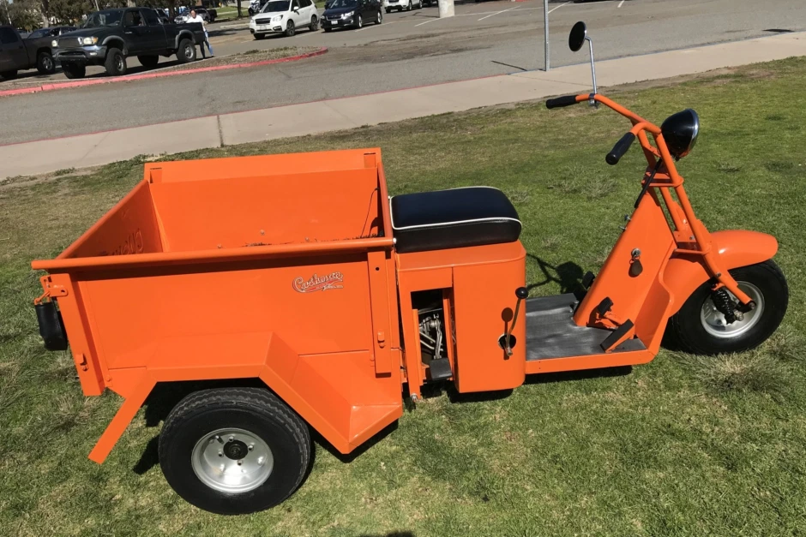

Figure 6: Cushman Truckster (1954) [13]

### Subsystem Level State of the Art Benchmarking

Now that each product has been looked at on a general basis, the group can look into more detailed aspects of the system and compare those. The three subsystems that will be discussed are the dumping mechanism, the tires/traction, and the motor/power of each product. The reason behind looking at smaller aspects of these designs is to get a better understanding of each component so that the group can put what works best on their overall system.

#### Subsystem #1: Dumping Mechanism

After the workers deliver the compest to the designated place, our team hopes that our equipment will have a dumping mechanism. Specifically, one end of the trailer will be fixed and then the other end will be lifted up. Then the compost will be poured out due to gravity, which will make the whole equipment more convenient to operate. Also, it can improve the work efficiency and reduce the workload of the workers.

##### Existing Design #1: Wheelbarrow

This existing design is probably the most basic of them. It has small dimensions and light-weight, and workers can easily lift the wheelbarrow by hand to realize dumping. This dumping mechanism is suitable for the time when the weight of compost is light and the transportation distance is short.

##### Existing Design #2: Gorilla Cart

This existing design has a hydraulic rod, and a motor is installed on the trailer to drive the hydraulic rod, workers can remotely control the motor to control the extension of the hydraulic rod, which can realize automatic dumping.

##### Existing Design #3: Cushman Truckster

This design has two wheels instead of having only one wheel. It has small dimensions and light-weight, workers can grab the hook as a handle to lift the trailer.

#### Subsystem #2: Tires/Traction

Tires are a really important subsystem for our design. The tires are what allows the device to travel to and from places much easier. Along with the type of tires, the number of tires also affects the design differently. Our client has stated 3 or 4 tires is the most desirable for our final design. A description of the tires for the existing designs is found below.

##### Existing Design #1: Wheelbarrow

Wheelbarrows usually have one tire to give the device the ability to push and turn around faster. This 360 rotation allows the user to be able to push big loads in all directions.

##### Existing Design #2: Gorilla Cart

Gorilla Carts are equipped with four off-road tires. These carts are known for having durable wheels, as many of them are foam filled or partially foam-filled. This allows for a larger weight capacity without blowing a tire off.

##### Existing Design #3: Cushman Truckster

The Cushman Truckster comes with three wheels, which allows for sharper turns. The downside to this product’s tires is that they are small tires that are typically street-tread. This wouldn’t be ideal for rough, dirt roads.

#### Subsystem #3: Motor/Power

The powering of the system is a really big part of the design. Without a way to power it, the cart will not move and therefore defeats the purpose of the design. The team has discussed this subsystem with the client and had agreed we want our final design to have a motor to travel to and from the disposal site as well as making it human powered for shorter distances.

##### Existing Design #1: Wheelbarrow

For the first design, a wheelbarrow, it is strictly human powered. The wheelbarrow is only capable of moving if a human or animal pushes it. This is one of our requirements but is lacking the motor powered requirement the client wants.

##### Existing Design #2: Gorilla Cart

The Gorilla cart is similar to the wheelbarrow but has four wheels rather than one. It is also solely based on human or animal power and is therefore lacking the motor power the client wants.

##### Existing Design #3: Cushman Truckster

The last existing design is the cushman truckster. This design is motorized, but lacks the operator power. The team's overall goal is to come up with a design that incorporates all three of the existing designs into one and fits our clients needs.

# CONCEPT GENERATION

Now that a Benchmarking Analysis has been completed, the group could start to come up with concepts for this project. The benchmarking allowed for the group to find what will work and what will not for this project. In this chapter, the group discusses three of the six alternative designs in depth, using both a Full-System analysis and a subsystem analysis. These three designs were chosen to go into detail because these three are very different from each other and offer the most variety in combinations. These three alternatives allow the group to compare specific parts of each design to each other in order to make the best choice for this project. The rest of the designs can be seen in Appendix A.

## Full System Concepts

Below are three design concepts that the group has come up with. Each one will be compared both at a full system level and a subsystem level. This section covers the Full system level where each design will be compared to each other as a whole and how each one fits the customer needs in some way, if at all.

### Full System Design #1: Off-road Self-propelled Wagon

This design is a self propelled vehicle, using an AC motor and remote control to operate and handle it. Inside, there is a hydraulic piston-like assembly that retracts when a load is being hauled and can be expanded at the push of a button when ready to push the load out. This concept works well in many ways but also fails in others.This design works well because it completely eliminates human power. The operator will just walk along with it and be sure that nothing goes wrong along the way. Another way this exceeds is by the load. The load can be stored and released just as easily. One of the main problems is functionality. This design heavily relies on technology and a good radio frequency connection. If the remote or wagon batteries die, it becomes a completely useless piece of machinery until the battery is replaced. Because of this, this design is not maintainable, nor is it easy to operate due to the wide array of technological controls.

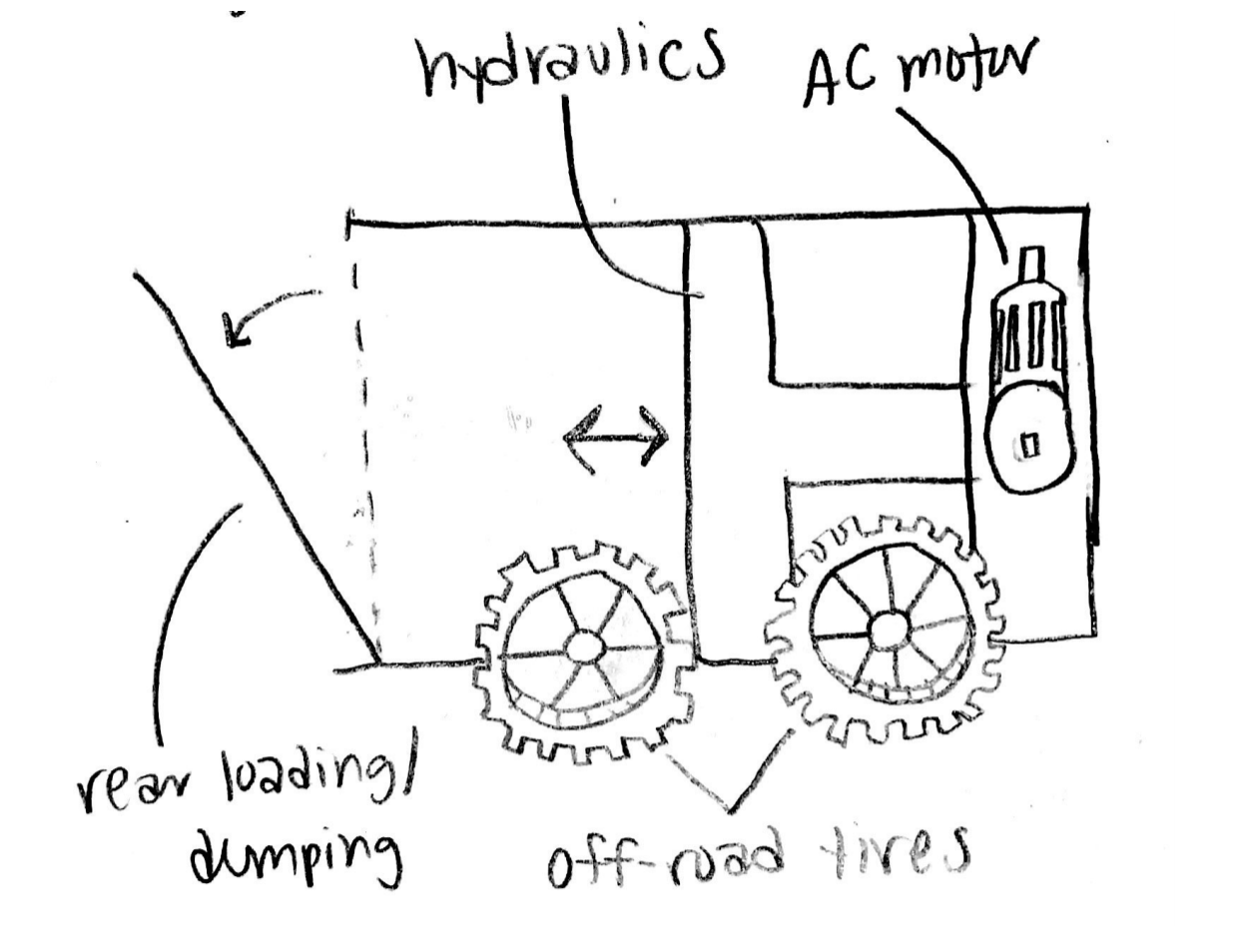

Figure 7: First Design, labeled the Self-Propelled Wagon

### Full System Design #2: Bicycle on Tracks

This design, as shown below, is a motorized wagon that the user rides to and from their destination. The piece that sets this off from the rest is the traction. Instead of using tires, this design brings in the concept of tracks, similar to that of a tank. This design heavily focuses on satisfying the need for traction and durability. This is also a design that would be relatively easy to operate. There are a number of problems that make this design not ideal, however. The first problem is maintaining the product. Tracks can be very expensive and very difficult to replace. Not only that, but this design is similar to the first in the way that this would be dead weight if a batter were to die. Another possible problem is that the cargo capacity would probably be very minimal to decrease the overall length of the concept. There are a number of things that would need to be improved if this design is chosen.

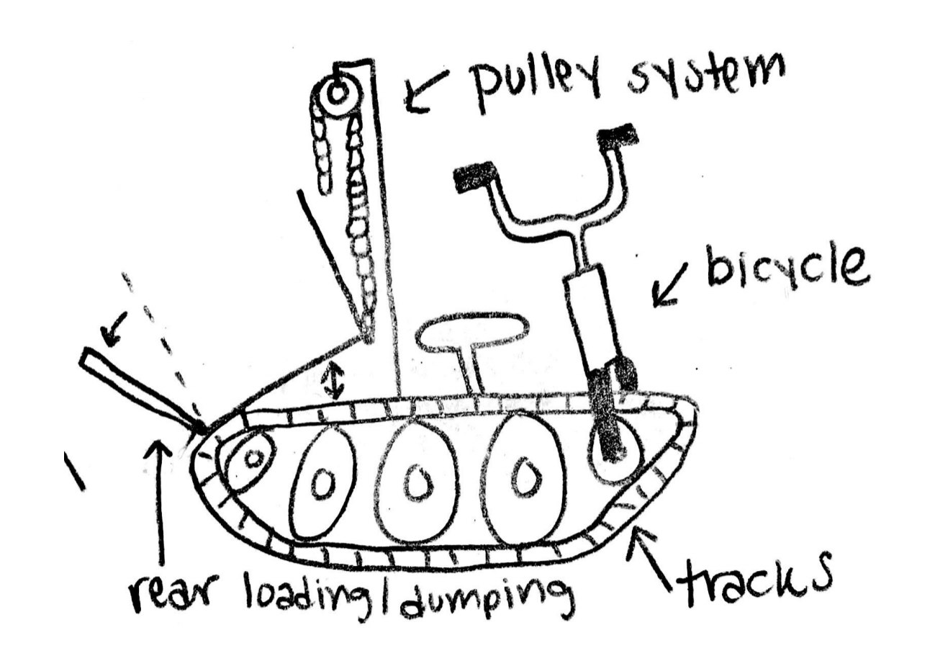

Figure 8: The second design, a Bicycle on Tracks similar to a tank’s

### Full System Design #3: Off-Road Wagon

This final design is one of the simplest, yet possibly one of the most practical. It uses off-road wheels and a hydraulic lifting system to dump the load. The cart is electrically propelled and guided by an operator on a handle. This design is very maneuverable and maintainable, as there aren’t many electrical components nor are there many complex pieces. The advantage that this design has over the rest is that it can be both electrically assisted or solely human-powered. This way, if the battery dies, the cart can still be used to an extent until the battery is charged or replaced. The largest downside to this design is that it may not do the best in muddy terrain, but this depends mainly on the size and clearance of the cart.

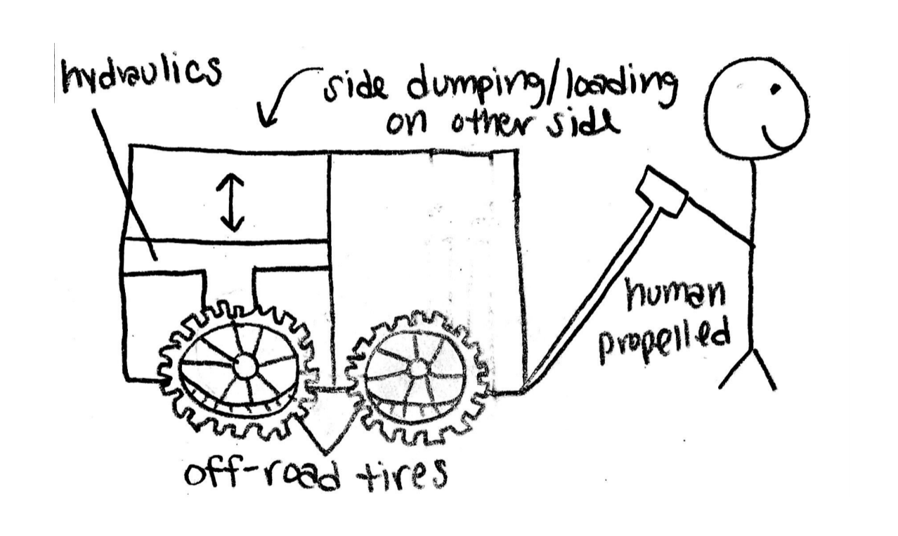

Figure 9: The third design, simply labeled the Off-Road Wagon.

## Subsystem Concepts

These designs can be broken down into more specific areas. As with the Existing Products, these design alternatives were looked at more closely. This is an important part of the design process because it allows the user to see how each of the important components of the project are reflected in each design. Below are subsystems that were incorporated into the design alternatives. Within each subsystem, there are multiple designs that have been compared to one another in order to determine which would be best for this project.

### Subsystem #1: *Dumping Mechanism*

What our team needs to do is to fix one end of the trailer with screws, and then lift up the other end. Due to the effect of gravity, the compost will be poured out to realize dumping. This will reduce the burden on workers and improve work efficiency.

#### Design #1: Hydraulic System

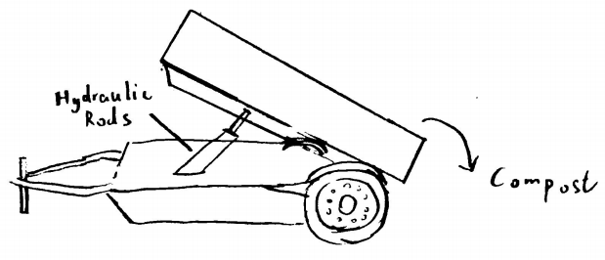

Figure 10: Dumping Mechanism - Hydraulic System

The workers will remotely control the motor to control the expansion and extension of the hydraulic rod to realize dumping.

Advantages: Operate remotely; Automatic dumping.

Disadvantages: High manufacturing costs; High maintenance costs.

#### Design #2: Screw Jacks

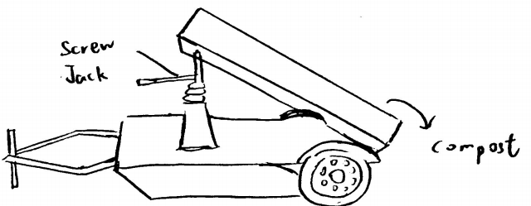

Figure 11: Dumping Mechanism - Screw Jacks

The workers will use a screw jack to lift one end of the trailer to achieve dumping.

Advantages: Low manufacturing costs; Low maintenance costs.

Disadvantages: Vibration during the process (unstable); Workers need to turn the handle on the jack by hand.

#### Design #3: Scissor Lift

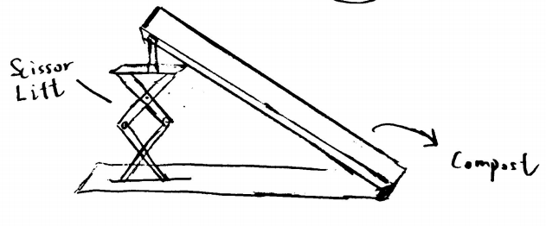

Figure 12: Dumping Mechanism - Scissor Lift

Our team will weld the scissor lift with the trailer before, and lift the trailer through remote control of scissor lift's expansion and contraction.

Advantages: Operate remotely; Automatic dumping.

Disadvantages: High manufacturing costs; High maintenance costs.

### Subsystem #2: *Tires/Traction*

Based on our needs, tires are so important for the stability of our vehicle. Moreover, tires can determine if our vehicle can go through the rough terrain in Malawi without failing by getting stuck or simply getting punctures. So, tires can determine if our vehicle can run efficiently as intended, which means that tires are a very essential part of our project.

#### Design #1: Air Filled Tires

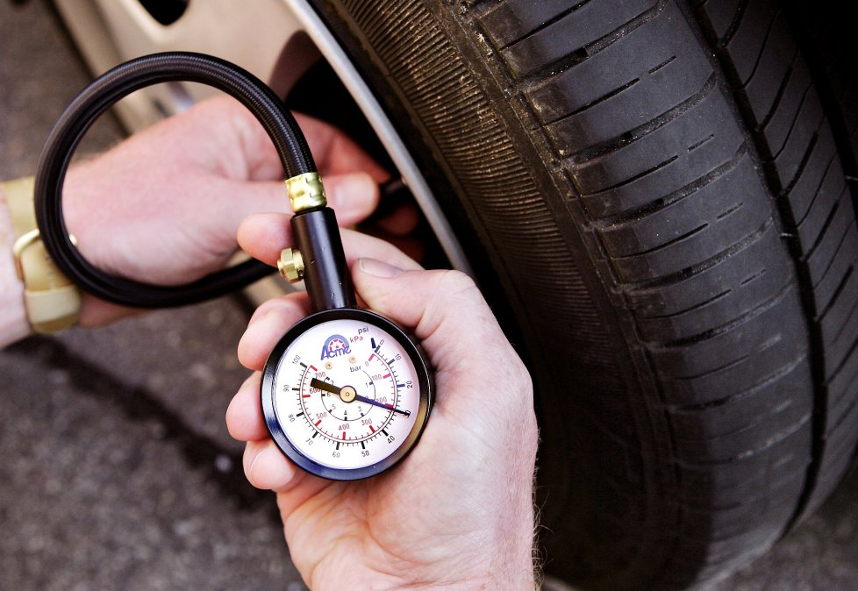

Figure 13: Tires/Traction - Air Filled Tires

Rubber tires filled with air, which is pretty common on most cars and cost efficient.

Advantages: Cost efficient; easily inflatable .

Disadvantages: Durability; Prone to Punctures.

#### Design #2: Regular Foam Filled Tires

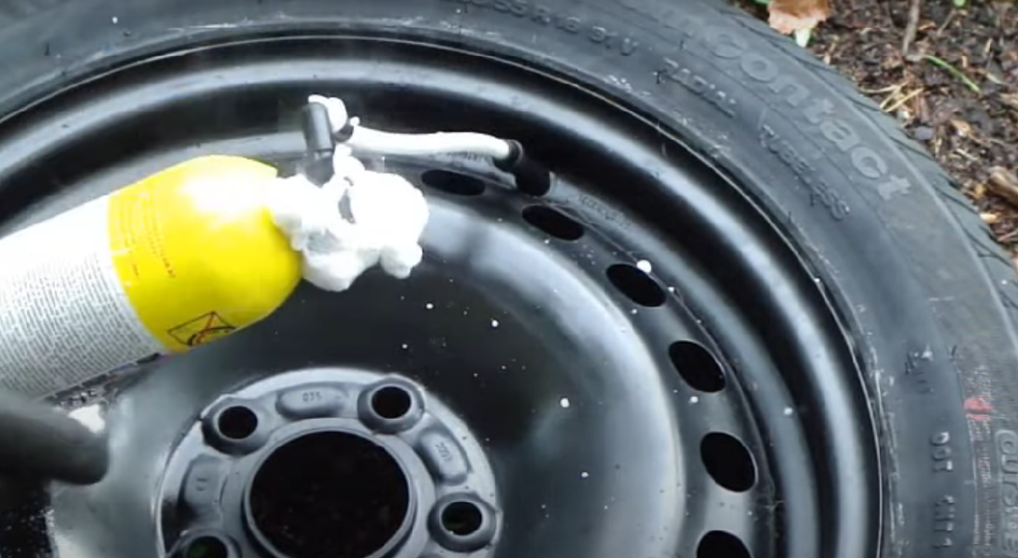

Figure 14: Tires/Traction - Regular Foam Filled Tires

Rubber tires filled with foam, which is a great idea for shock absorbent.

Advantages: Shock absorbant; more flexibility.

Disadvantages: More materials needed; needs a sealant to the rim.

#### Design #3: Sealant Foam Filled Tires

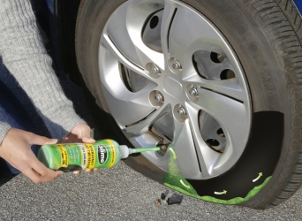

Figure 15: Tires/Traction - Sealant Foam Filled Tires

Rubber tires filled with sealant foam, which is a concept that has been around for a few years.

Advantages: Availability; easy to get in the market, Sealant; It’s a rim-tire sealant foam.

Disadvantages: Cost; More expensive on the budget.

### Subsystem #3: *Motor/Power*

The team has discussed with the client the multiple ways to power a cart and has decided on one which we believe fits Malawi and the people of Malawi's needs. Below is a more in depth description of the design we have chosen and why.

#### Design #1: Operator and Motor Powered

The team has decided to have two different ways to power the cart including operator power and motor power. We will use an AC motor to power the device when it needs to go long distances such as to and from the disposal site, and human powered when traveling shorter distances like to and from each house. Only using the motor during long distances will make it last longer because it won’t be running all day. This will also save money and make the motors have a longer life span. We believe incorporating both of these fits the customer needs the best and will be the most beneficial to the people of Malawi.

# DESIGNS SELECTED – First Semester

In Designs Selected, we will combine the subsystems we come up with and create the concepts. Then we got our six designs which are shown in Appendix A. Firstly, we will use the Pugh Chart to narrow six designs down to three by ranking them based on customer needs. Then we will use the Decision Matrix to decide our top one design based on engineering requirements. Another design will be decided by team members to make up for the deficiencies of the design selected by decision matrix.

## Technical Selection Criteria

In the Pugh chart, we first chose this tricycle as the datum because it embodied the basics of the criteria outlined. Then, we analyzed the ability of the alternative designs to perform against the datum based on customer needs. This decision was made clear to us when we saw how many positives and how few minus marks each design garnered.After all of the designs were compared to the datum, it became clear that the three top design alternatives were designs one, four, and five. Design alternative 2 is a bicycle on truck, our team thinks it is not manufacturable, meanwhile it uses a pulley system as the dumping mechanism, which means it is not gonna be easy for the workers to operate when dumping. Also, this design is not equipped with any motors, so it has a low score in rechargeable. Similarly, design alternatives 3 and 6 are not equipped with any motors as well, also because they're all hand propelled, these two designs have lower capacity compared with other alternatives.

Alternatives 1, 4, and 5 are the 3 top designs, they perfectly satisfy most of the customer needs. But they also have disadvantages. For instance, alternative 1 is hand propelled, alternative 5 is not easy to operate because of the use of the pulley system. Alternative 4 uses an AC motor and a hydraulic system so the Manufacturing cost is gonna be high.

## Rationale for Design Selection

In order to narrow the three alternatives to one, we used the decision matrix to check how well the selected alternatives could fulfill certain engineering requirements. First, our team gave each engineering requirement different weightings according to their importance. Among them, Increase Waste Capacity is the most important, followed by Small Dimensions and Decrease Manufacturing Cost. Then, we gave a score out of 5 for each criterion with one being the lowest and 5 being the highest. The final score of an alternative would be a weighted score. For both Off-Road Self Propelled Wagon and Pulley Wagon, their structures are not simple so they don’t have small dimensions, meanwhile, their manufacturing costs are high. Thus, after scoring all the three alternatives, we found out that off-road wagons best fulfilled the engineering requirements.

Because this is a hand-propelled design, we also plan to design a trailer driven by a motor, shown as follows.



Figure 16: Dump Trailer with Motor

By starting the built-in motor of the trail, it will move forward by itself, while the workers only need to use the bicycle in front of the guide direction.

All in all, the final designs of our team are off-road wagons and a dump trailer with a motor.

# REFERENCES

[1] N. Takesue, Y. Komoda, H. Murayama, K. Fujiwara and H. Fujimoto, "Scissor lift with real-time self-adjustment ability based on variable gravity compensation mechanism", *Advanced Robotics*, vol. 30, no. 15, pp. 1014-1026, 2016. Available: 10.1080/01691864.2016.1181008.

[2] A. Noormohamed, O. Mercan and A. Ashasi-Sorkhabi, "Optimal Active Control of Structures Using a Screw Jack Device and Open-Loop Linear Quadratic Gaussian Controller", *Frontiers in Built Environment*, vol. 5, 2019. Available: 10.3389/fbuil.2019.00043.

[3] P. Gallina, "Vibration in screw jack mechanisms: experimental results", *Journal of Sound and Vibration*, vol. 282, no. 3-5, pp. 1025-1041, 2005. Available: 10.1016/j.jsv.2004.03.036.

[4] Xiang Sunshou Seeks Patent for Garbage Recycling Vehicle with Hydraulic Lifting Rods. (2018). Global IP News. Environmental Patent News, pp. Global IP News. Environmental Patent News, 2018-04-08.

[5] J. Wang, Z. Qi and G. Wang, "Hybrid modeling for dynamic analysis of cable-pulley systems with time-varying length cable and its application", *Journal of Sound and Vibration*, vol. 406, pp. 277-294, 2017. Available: 10.1016/j.jsv.2017.06.024.

[6] 8020.net. 2020. *Resources To Learn More About T-Slot Products And Narrow Down Your Options.*. [online] Available at: <https://8020.net/product-basics#> [Accessed 19 October 2020].

[7] Budynas, R., 2019. *SHIGLEY's MECHANICAL ENGINEERING DESIGN*. 8th ed. MCGRAW-HILL EDUCATION.

[8] Orosz, I., 1970. *Simplified Method For Calculating Shear Deflections Of Beams*. Madison, WI: USDA Forest Service, Forest Products Laboratory.

[9] Engineeringtoolbox.com. 2008. *Aluminum Alloys - Mechanical Properties*. [online] Available at: <https://www.engineeringtoolbox.com/properties-aluminum-pipe-d_1340.html> [Accessed 19 October 2020].

[10] Megson, T., 2005. *Structural And Stress Analysis*. 2nd ed. Boston: Elsevier Butterworth Heineman.

[11] Lowe's. 2020. *CRAFTSMAN 6-Cu Ft Steel Wheelbarrow*. [online] Available at: <https://www.lowes.com/pd/CRAFTSMAN-6-cu-ft-Steel-Wheelbarrow/1000737276> [Accessed 19 October 2020].

[12] Amazon.com. 2020. *Gorilla Carts GORMP-12 Steel Dump Cart With Removable Sides And 2-In-1 Convertible Handle, 1,200-Pound Capacity, 39.5-Inch By 22-Inch Bed, Grey Finish*. [online] Available at: <https://www.amazon.com/Gorilla-Carts-GORMP-12-Removable-Convertible/dp/B00814KE5I> [Accessed 19 October 2020].

[13] The best vintage and classic cars for sale online | Bring a Trailer. 2020. *1954 Cushman Truckster Pickup*. [online] Available at: <https://bringatrailer.com/listing/1954-cushman-truckster/> [Accessed 19 October 2020].

[14] University of Colorado Boulder, “8. DC vs. AC Motors - DC Motor Control and Stepper Motors,” *DC vs. AC Motors*. [Online]. Available: https://www.coursera.org/lecture/motors-circuits-design/8-dc-vs-ac-motors-gf0y2. [Accessed: 19-Oct-2020].

[15] All About Circuits, “Brushless DC Motor: AC Motors: Electronics Textbook,” *What's the difference between brushless DC motors and AC motors?* [Online]. Available: https://www.allaboutcircuits.com/textbook/alternating-current/chpt-13/brushless-dc-motor/#:~:text=Brushless DC motors are similar,torque in a magnetic rotor. [Accessed: 19-Oct-2020].

[16] RS Components Ltd., “The Complete Guide toAC Motors,” *Everything You Need To Know About AC Motors | RS Components*. [Online]. Available: https://uk.rs-online.com/web/generalDisplay.html?id=ideas-and-advice/ac-motors-guide. [Accessed: 19-Oct-2020].

[17] Balls Out Motors, “Golf Cart Buying Guide,” *NEW & USED GOLF CART BUYING GUIDE*. [Online]. Available: https://www.ballsoutmotors.com/golf-cart-buying-guide/#:~:text=Most newer golf carts now,more pulling power up hills. [Accessed: 19-Oct-2020].

[18] Electric beach wagons, *Sandhopper.com & Electricbeachwagons.com*. [Online]. Available: https://electricbeachwagons.com/. [Accessed: 19-Oct-2020].

[19] “Why foam-filled tyres are the best choice for your telescopic boom lift,” *Why foam-filled tyres are the best choice for your telescopic boom lift | TVH Parts*, 19-Apr-2019. [Online]. Available: https://www.tvh.com/blog/why-foam-filled-tyres-are-the-best-choice-for-your-telescopic-boom-lift. [Accessed: 19-Oct-2020].

[20] “Manufacture of microcellular foam tires,” *Google Patents*, 20-Jul-2010. [Online]. Available: https://patents.google.com/patent/US5229047A/en. [Accessed: 19-Oct-2020].

[21] N. Ward and T. Young, *The complete guide to glues & adhesives*. Iola, WI: Krause Publications, 2001.

[22] “Effects of Summer Heat on Adhesives,” *Bond Tech Industries*, 22-Jul-2015. [Online]. Available: https://www.bond-tech-industries.com/effects-of-summer-heat-on-adhesives/. [Accessed: 19-Oct-2020].

[23] HNX Media, “Expanding Foam In A Tire,” *YouTube*, 14-May-2019. [Online]. Available: https://youtu.be/chcEBR4h8Is. [Accessed: 18-Oct-2020].

# APPENDICES

## Appendix A: All six of the Design Alternatives.



Figure A1: Design Alternative 1

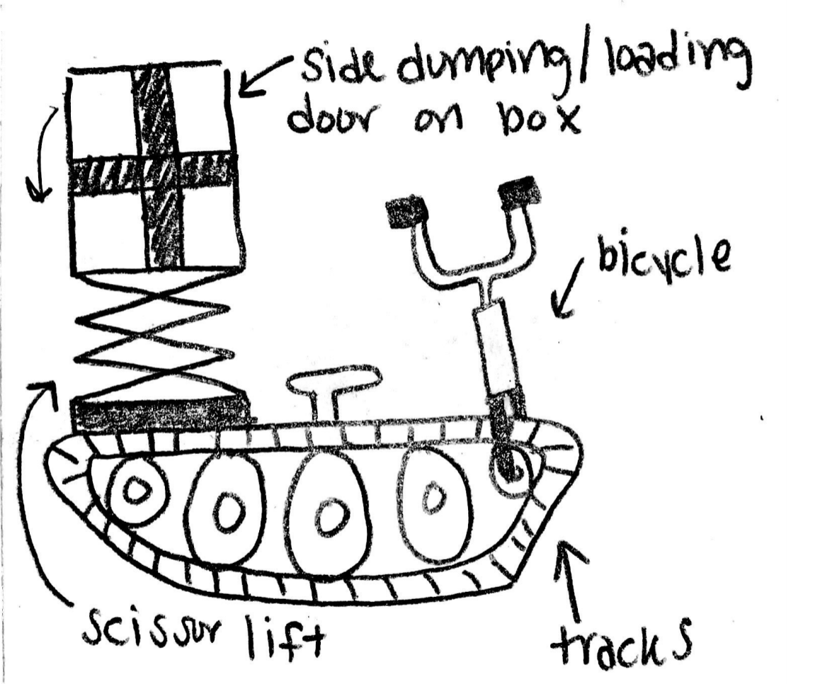

Figure A2: Design Alternative 2



Figure A3: Design Alternative 3



Figure A4: Design Alternative 4

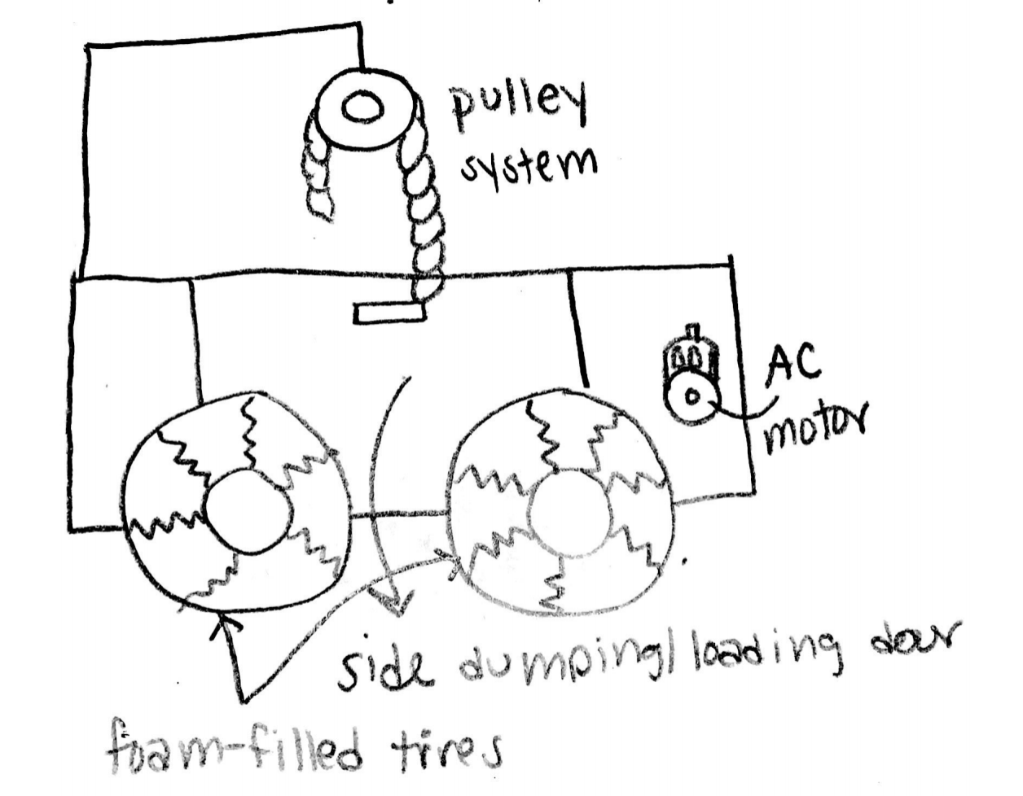

Figure A5: Design Alternative 5

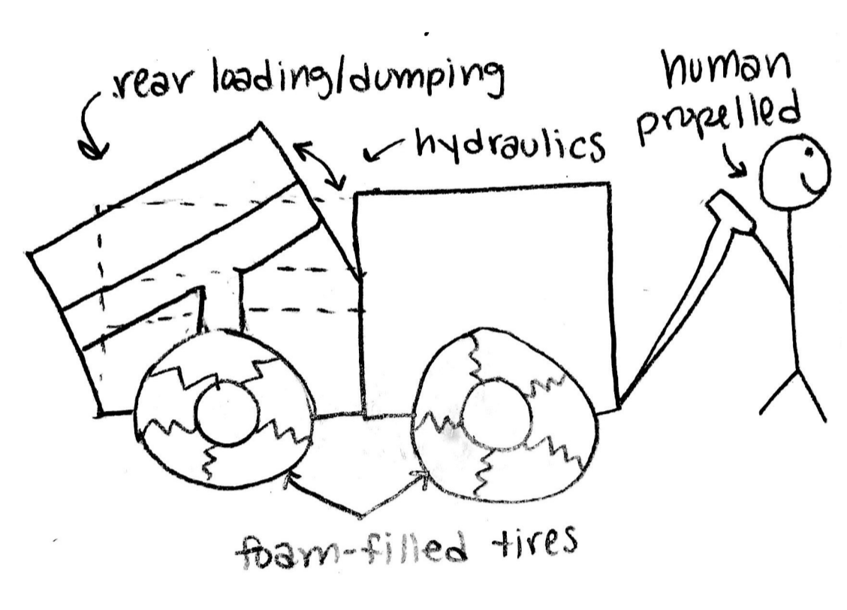

Figure A6: Design Alternative 6

## Appendix B

Table 1: Pugh Chart

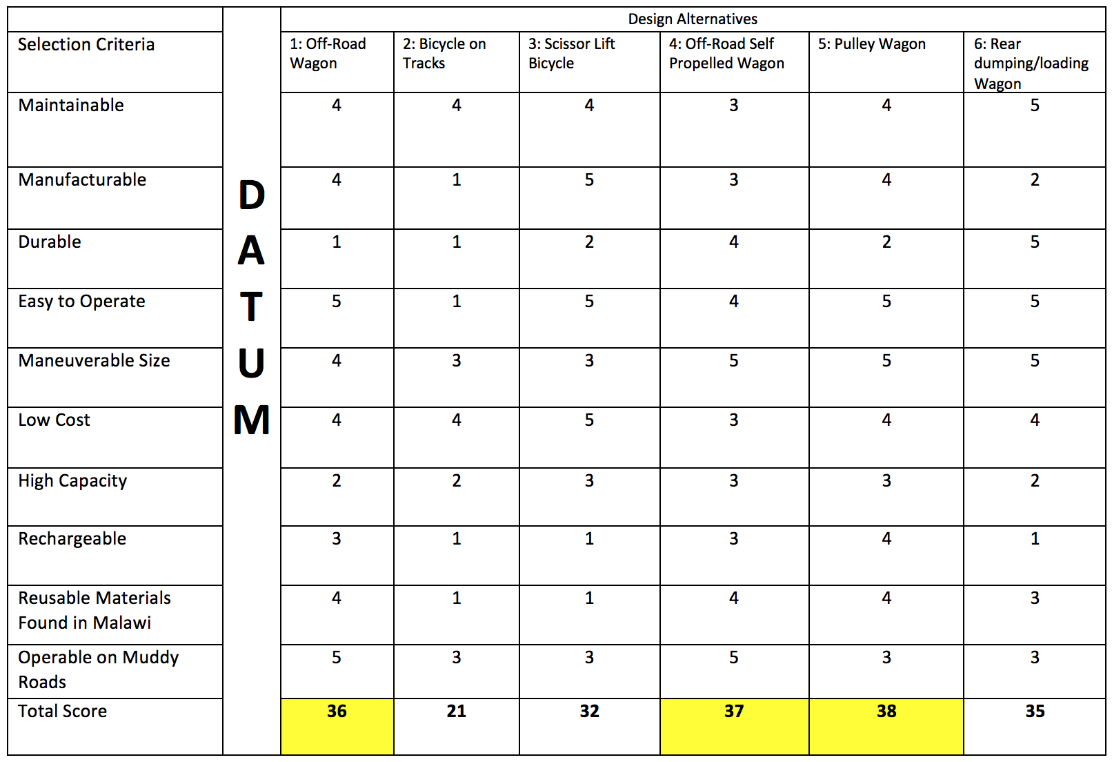

Table 2: Decision Matrix

|  |  |  |  |  |  |  |  |
| --- | --- | --- | --- | --- | --- | --- | --- |
|  |  | Off-Road Wagon | | Off-Road Self Propelled Wagon | | Pulley Wagon | |
| Criteria | Weight (%) | Score | Weighted Score | Score | Weighted Score | Score | Weighted Score |
| Increase Power | 15 | 1 | 0.15 | 4 | 0.6 | 4 | 0.6 |
| Small Dimensions | 20 | 5 | 1 | 2 | 0.4 | 2 | 0.4 |
| Increase Waste Capacity | 25 | 3 | 0.75 | 3 | 0.75 | 4 | 1 |
| Increase Battery Life | 10 | 1 | 0.1 | 3 | 0.3 | 2 | 0.2 |
| Decrease Weight | 10 | 5 | 0.5 | 3 | 0.3 | 3 | 0.3 |
| Decrease Manufacturing Cost | 20 | 5 | 1 | 1 | 0.2 | 1 | 0.2 |
| Total |  |  | 3.1 |  | 2.55 |  | 2.7 |

Table 3: Bill of Materials

|  |  |  |  |  |
| --- | --- | --- | --- | --- |
| Item # | Description | Vender | Quantity (#) | Price ($) |
| 1 | Off-Road Tires | GoPowerSports | 4 | 200 |
| 2 | Hydraulic System | TBD | 1 | TBD |
| 3 | 80/20 Cart | 80/20 Inc. | 1 | $581 |
| 4 | 80/20 side door | 80/20 Inc. | 1 | $45 |
| 5 | Motor | Electric Motor Warehouse | 1 | $100-400 |